LS1: You and your company

The Company and its departments

Tom is an employee at iBot -SR, a company which provides software for robotics equipment used in production and manufacturing. He is preparing an introduction in English for a new colleague, Piotr, who has moved from Poland for a job as a software tester. It is Tom’s task to explain the company and its departments to him.
A Company Website
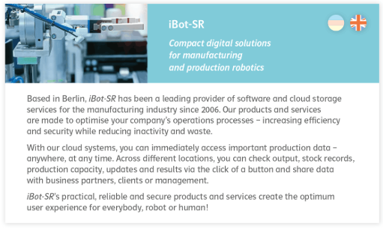
Task1:
Match the English words with the German translation.
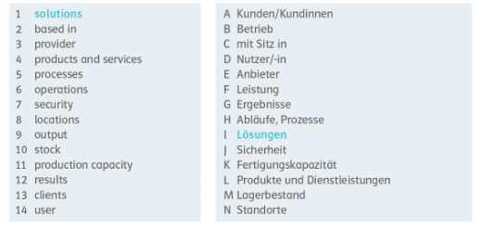

Task 2:
Answer the following questions and add 2-3 sentences with information about what iBot-SR does.

- State when the company was founded and where the company headquarters are. 2006/Berlin
- Write down the products and services provided by Ibot-SR. Software/cloud storage
- State for who the products and services are for. Manufacturing and production companies

Task 3: Listening

Listen to the audio and complete the tasks:

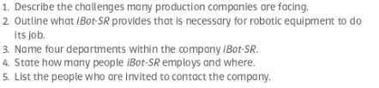

- High consumer demands, shorter time frame, personnel and supply shortages
- Software to organise and optimize usage of robotic manufacturing
- Research and development, engineering and testing, quality control, HR (human resources), finance and accounts
- Almost 2000 (staff members) in Germany, Austria, Poland and Romania
- Customers, partners, people interested in working for the company

Word help:

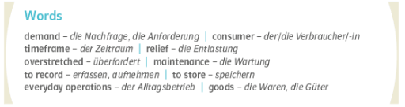

Task 4: Company departments

Match the English department with the German translation.

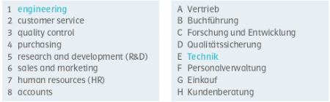

Task 5: What does each department do? Match the words and phrases to make sentences.

